**Chocoholics Anonymous Software Product**

The Chocoholics Anonymous Software Product will allow all people that are associated with the Chocoholics Anonymous program an easier way of accessing and modifying data. The product will allow the providers a way to verify a members’ status. If they are an active member the product allows the provider to submit a claim for a specific service they have provided to a member. The data that is entered by a provider, operator, or manager, can be easily maintained by a Chocoholics Anonymous operator. The Chocoholics Anonymous manager can generate all of the reports at the end of the week or when requested.

Nouns in the paragraph:

Chocoholics Anonymous Software Product: The product to be created

People: manager, operator, provider, member, entity class

Data: Describes all of the information in the Chocoholics Anonymous system

Members’ status: attribute of a member

Claim: entity class

Service: entity class

Provider: entity class

Member: entity class

Operator: not an entity class, but does play a role

Manager: not an entity class, but does play a role

Chocoholics Anonymous State Chart

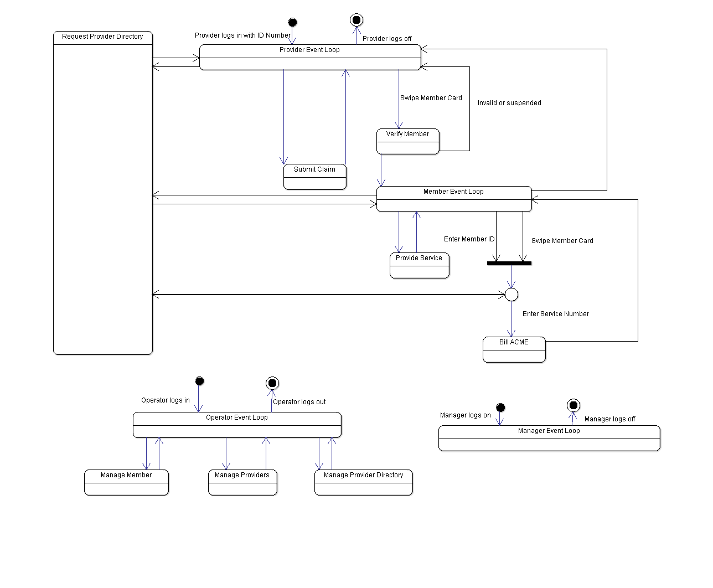

**Chocoholics Anonymous Sequence Diagrams**

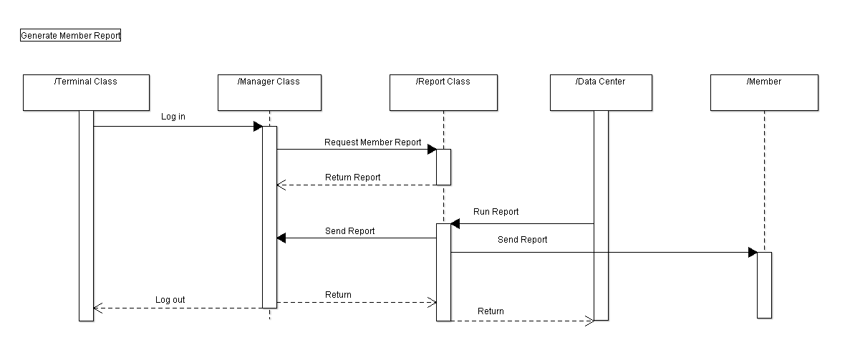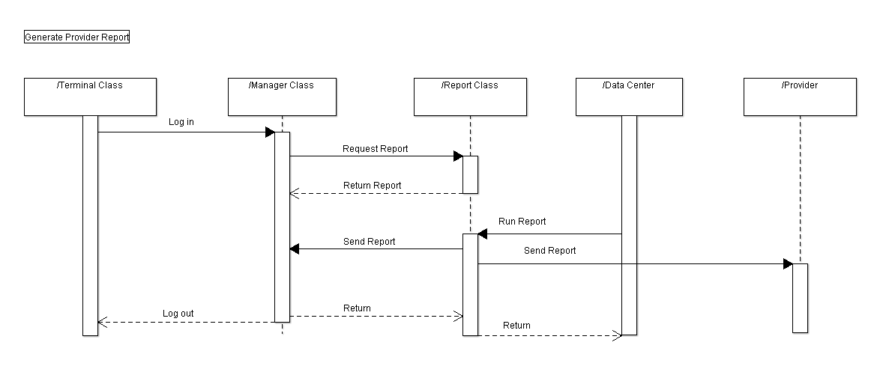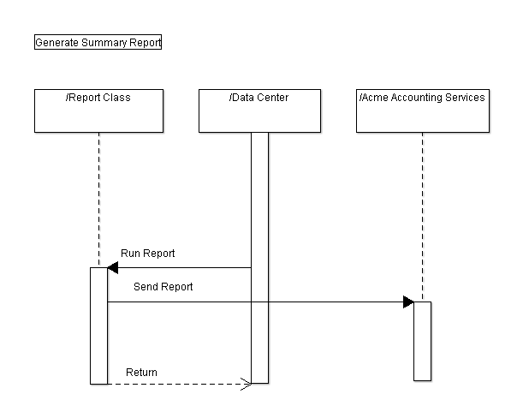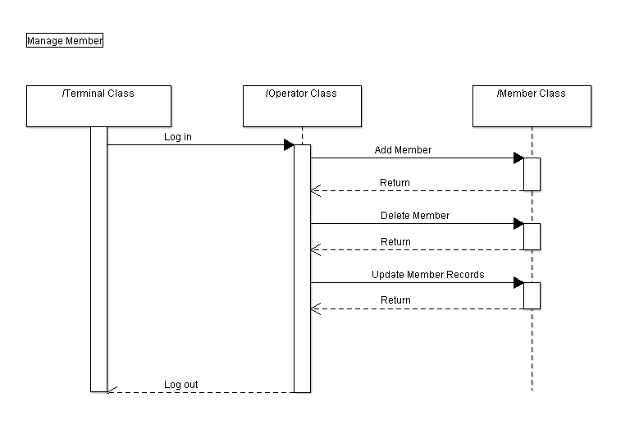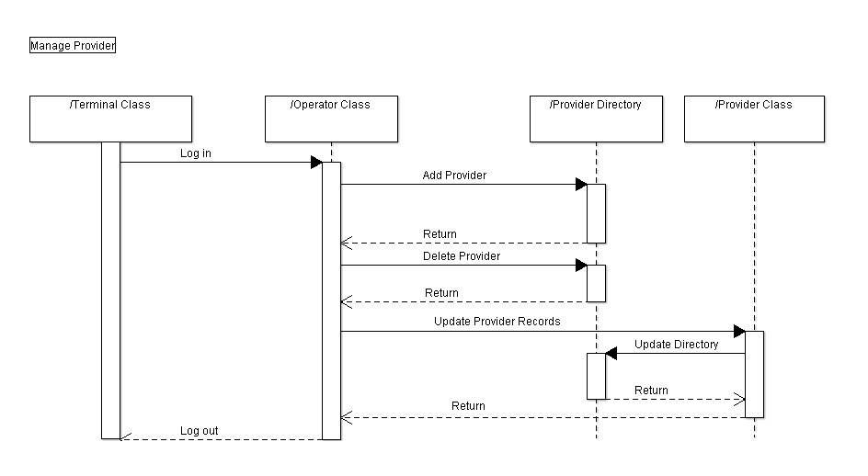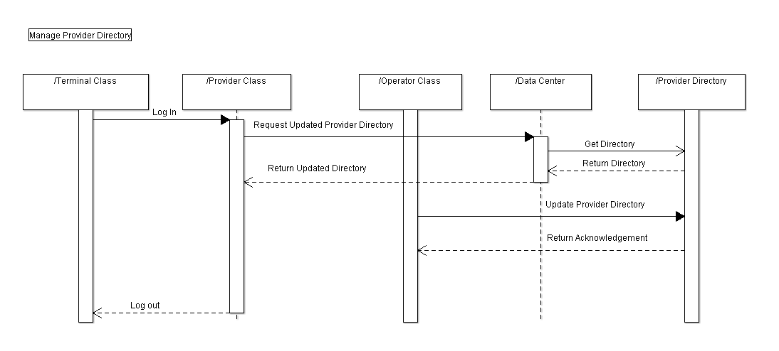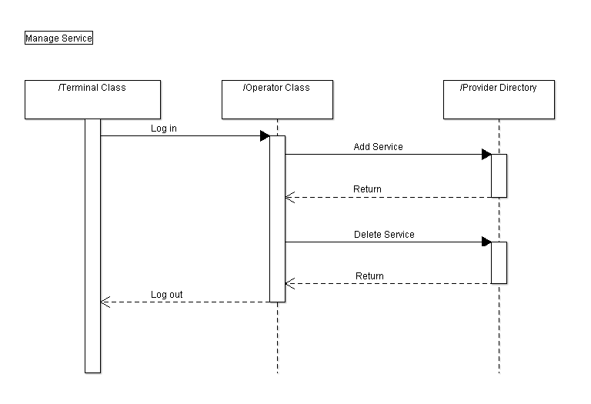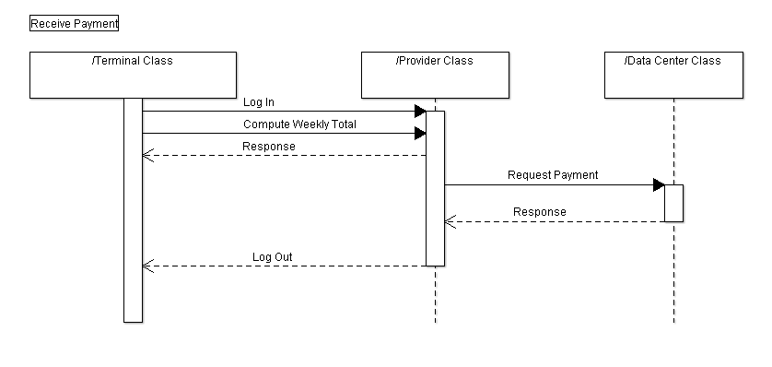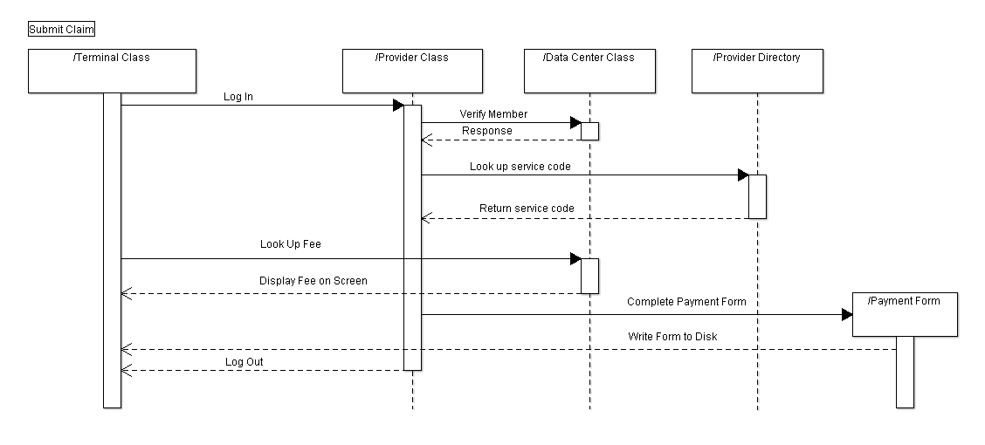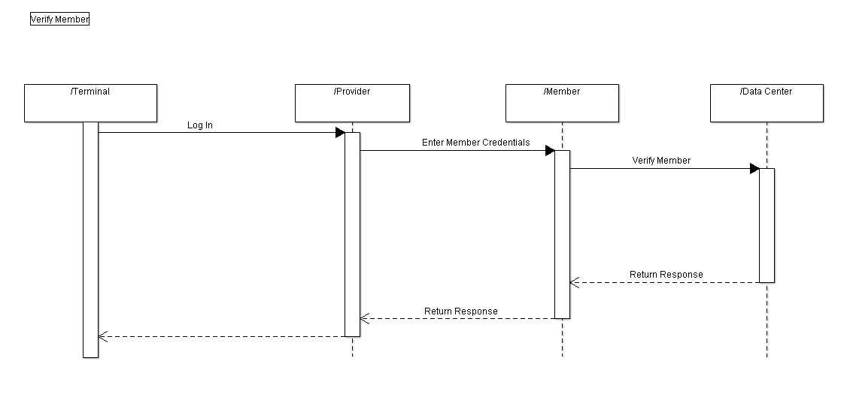

**Time and Percentage Log**

**Task**

1. Create Glossary-

Josh Cutolo- 14 Oct 15 33%

Josh Pinos- 14 Oct 15 33%

James Fisher- 14 Oct 15 33%

2. Create Use Case Diagram-

Josh Cutolo- 19-20 Oct 15 33%

Josh Pinos- 19-20 Oct 15 33%

James Fisher- 19-20 Oct 15 33%

3. Create Version Control Log File , and Time and Percentage Log–

Josh Cutolo- 20 Oct 15 33%

Josh Pinos- 20 Oct 15 33%

James Fisher- 20 Oct 15 33%